Please ensure you have filled in all the details required above.  
Please also mark up where each advisor will be sitting, please write their full names.

**ASAP** return the completed form to [laestimates@parliament.wa.gov.au](mailto:laestimates@parliament.wa.gov.au)

**COMMITTEE B - LEGISLATIVE COUNCIL CHAMBER ONLY  
DIVISION No. or Off budget:**

**Relevant Minister:**

**Hearing date/time block:**

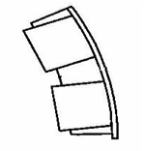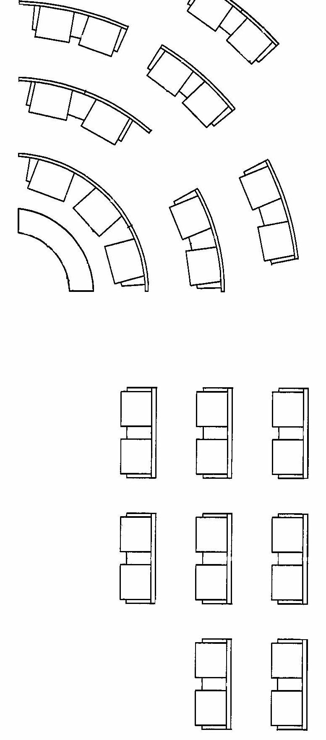



18

19

17

16



15

14

13

12

11

10

The Minister

1

4

5

6

7

2

3

8

9

14

15

16

11

12