**COMMITTEE A - LEGISLATIVE ASSEMBLY CHAMBER ONLY   
DIVISION No. or Off budget:**

**Relevant Minister:**

**Hearing date/time block:**

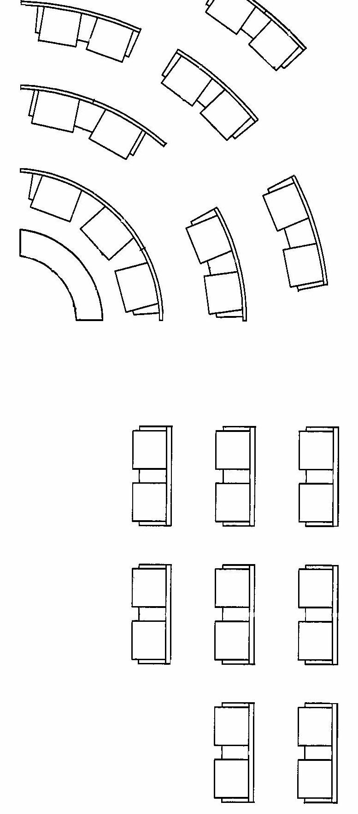

The Minister

10

3

6

5

2

4

1

7

100000

11

13

12

14

15

9

8

18

17

16

Please ensure you have filled in all the details required at the top.   
Please also mark up where each advisor will be sitting, please write their full names.

**ASAP** return the completed form to [laestimates@parliament.wa.gov.au](mailto:laestimates@parliament.wa.gov.au)

6

5

4

3

2

1